Supplementary information

Network analysis of the genetic relationships between twenty psychiatric and substance use disorders

Kenneth S. Kendler, Henrik Ohlsson, Jan Sundquist, Kristina Sundquist

World Psychiatry

Table 1 Description of registers

The Register of Total Population (RTB), maintained by Statistics Sweden (SCB), contains data on all individuals registered as residents in Sweden. It is based on the Swedish Tax Agency’s population registration system and includes demographic, household, and relational information such as personal identity number, age, sex, marital status, country of birth, citizenship, family and household identifiers, and dates of key life events (e.g., migration, marriage, death). RTB serves as the foundation for official population and household statistics and is updated monthly, with annual person-level data available since 1968 and household data since 2011
Statistics Sweden (SCB). (2024).
Registret över totalbefolkningen (RTB) [Register of Total Population]. Retrieved from https://www.scb.se/vara-tjanster/bestall-data-och-statistik/register/registret-over-totalbefolkningen-rtb/

The Swedish National Prescribed Drug Register contains data on all dispensed prescription medications in Sweden since July 2005. It is based on information reported by pharmacies to the Swedish eHealth Agency and includes details such as the Anatomical Therapeutic Chemical (ATC) code, dosage, quantity, date of dispensing, prescriber information, and patient identifiers (encrypted for research use). The register covers all outpatient prescriptions nationwide and is updated monthly. It does not include medications administered during inpatient care.
Swedish National Board of Health and Welfare. (2024). Läkemedelsregistret [National Prescribed Drug Register]. Retrieved from https://www.socialstyrelsen.se/statistik-och-data/register/alla-register/lakemedelsregistret/

The Swedish Population and Housing Census is a register-based census conducted by Statistics Sweden (SCB). It collects data on households, accommodation, and housing conditions for the entire population at a given point in time. The census integrates information from multiple administrative registers, including the population register and the dwelling register, to produce statistics on household composition, housing characteristics, and living conditions. Sweden transitioned to a fully register-based census after 1990, eliminating the need for questionnaires and enabling annual updates through administrative data.
Statistics Sweden (SCB). (2024). Register-based Population and Housing Census. Retrieved from https://www.scb.se/en/finding-statistics/statistics-by-subject-area/population-and-living-conditions/population-composition-and-development/register-based-population-and-housing-census

The Longitudinal Integrated Database for Health Insurance and Labor Market Studies (LISA), maintained by Statistics Sweden (SCB), integrates data from labor market, education, and social insurance registers. It includes all individuals aged ≥16 years (≥15 years since 2010) who were registered as residents in Sweden on December 31 each year, starting in 1990. LISA contains annual information on employment, income, education, sick leave, disability pension, unemployment benefits, social welfare payments, civil status, and migration. The database was created to support research on health and labour market outcomes and is updated annually
Statistics Sweden (SCB). (2019). LISA – Longitudinal integrated database for health insurance and labour market studies. Retrieved from https://www.scb.se/contentassets/1bfd261141bc4ddb8e28d4a2e260b690/lisa-bakgrundsfakta-1990-2017.pdf

The Multi-Generation Register is a comprehensive dataset comprising individuals who have been registered in Sweden since 1961 or who were born in 1932 or later. These individuals are referred to as index persons, and the register includes links between them and their biological parents. Currently, the register contains information on approximately 11 million index persons. The Multi-Generation Register forms part of the broader Total Population Register, with data sourced from the National Tax Board. Each year, a new version of the register is produced, incorporating new index persons born or immigrating during the year. The data from the Multi-Generation Register can be accessed for research and statistical purposes, offering valuable insights into familial and generational connections within Sweden. Further details about the content and data quality are provided in Statistics Sweden, Background Facts, Population and Welfare Statistics 2017:2, Multi-Generation Register 2016.

The National Patient Register (NPR) was established in the 1960s by the National Board of Health and Welfare to collect data on in-patients at public hospitals in Sweden. Initially, the register focused on psychiatric care patients and about 16% of those receiving somatic (general) care, covering only six of Sweden’s 26 county councils. In 1984, the Ministry of Health and Welfare, in collaboration with the Federation of County Councils, decided to make participation in the NPR mandatory for all county councils. By 1987, the register expanded to include all inpatient care across Sweden. Since 2001, NPR has been further broadened to cover outpatient doctor visits, including day surgery and psychiatric care, from both public and private healthcare providers. For more detailed information, you can visit the official site of the National Board of Health and Welfare: https://www.socialstyrelsen.se/en/statistics-and-data/registers/register-information/the-national-patient-register/

We also utilized data from Primary Care, which is a research dataset containing individual-level information on clinical diagnoses from primary healthcare centers in Sweden. By the end of the follow-up period, this dataset covered almost 100% of the population. Figure 1 below illustrates the percentage of the entire Swedish population residing in counties with access to primary care data over time. For more detailed information on this dataset, refer to the study: Sundquist, J., Ohlsson, H., Sundquist, K., Kendler, K.S. (2017) “Common adult psychiatric disorders in Swedish primary care where most mental health patients are treated”, published in BMC Psychiatry (17:235). The full article can be accessed here: https://doi.org/10.1186/s12888-017-1381-4.

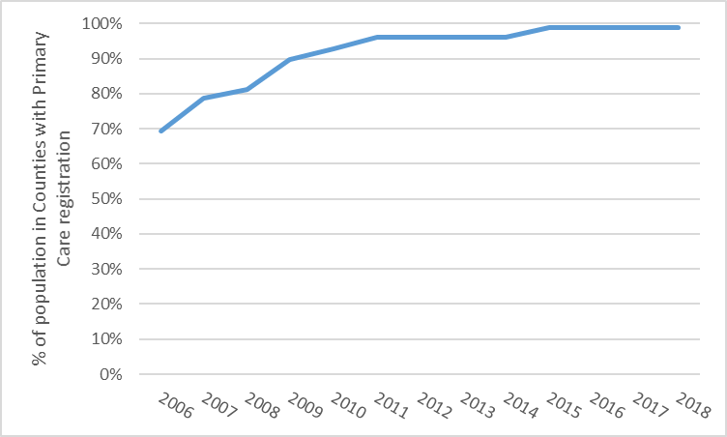

Figure 1 Percentage of the entire Swedish population that resides in counties with primary care data by year
Table 2 Definition of variables
 | Registers Used | Definition
Major Depression (MD) | The Swedish Hospital Discharge Register (coverage 1973-2018); Outpatient Care Register (national coverage 2001-2018); Primary Care Data (Partly coverage from 1999-2018) | ICD-8: 296.2, 298.0, 300.4; ICD-9: 296.2, 296.4, 298.0, 300.4; ICD-10: F32, F33.
Drug Use Disorder (DUD) | The Swedish Hospital Discharge Register (coverage 1973-2018); Outpatient Care Register (national coverage 2001-2018); Primary Care Data (Partly coverage from 1999-2018); the Swedish Drug Register (2005-2018); the Swedish Mortality Register, and the Swedish Criminal Register (1973-2018) and the Swedish Suspicion Register (1998-2018) | In the Swedish medical and mortality registries by ICD codes (ICD8: Drug dependence (304); ICD9: Drug psychoses (292) and Drug dependence (304); ICD10: Mental and behavioral disorders due to psychoactive substance use (F10-F19), except those due to alcohol (F10) or tobacco (F17)); in the Suspicion Register by codes 3070, 5010, 5011, and 5012, that reflect crimes related to DA; and in the Crime Register by references to laws covering narcotics (law 1968:64, paragraph 1, point 6) and drug-related driving offences (law 1951:649, paragraph 4, subsection 2 and paragraph 4A, subsection 2). DA was identified in individuals (excluding those suffering from cancer) in the Prescribed Drug Register who had retrieved (in average) more than four defined daily doses a day for 12 months from either of Hypnotics and Sedatives (Anatomical Therapeutic Chemical (ATC) Classification System N05C and N05BA) or Opioids (ATC: N02A).
Alcohol Use Disorder (AUD) | The Swedish Hospital Discharge Register (coverage 1973-2018); Outpatient Care Register (national coverage 2001-2018); Primary Care Data (Partly coverage from 1999-2018); the Swedish Drug Register (2005-2018); the Swedish Mortality Register, and the Swedish Criminal Register (1973-2018) and the Swedish Suspicion Register (1998-2018) | In the Swedish medical and mortality registries by ICD codes: ICD9: V79B, 305A, 357F, 571A-D, 425F, 535D, 291, 303, 980; ICD 10: E244, G312, G621, G721, I426, K292, K70, K852, K860, O354, T51, F10); in the Crime Register by codes 3005, 3201, which reflect crimes related to alcohol abuse; in the Suspicion Register by codes 0004, 0005 (Only those individuals with at least two alcohol-related crimes or suspicion of crimes from both Crime Register and Suspicion Register were included); in the Prescribed Drug Register by the drugs disulfiram (Anatomical Therapeutic Chemical (ATC) Classification System N07BB01), acamprosate (N07BB03), and naltrexone (N07BB04).
Obsessive-Compulsive Disorder (OCD) | The Swedish Hospital Discharge Register (coverage 1973-2018); Outpatient Care Register (national coverage 2001-2018); Primary Care Data (Partly coverage from 1999-2018) | ICD-9: 300D; ICD-10: F42
Attention-Deficit/Hyperactivity Disorder (ADHD) | The Swedish Hospital Discharge Register (coverage 1973-2018); Outpatient Care Register (national coverage 2001-2018); Primary Care Data (Partly coverage from 1999-2018) | ICD-9: 314; ICD-10: F90
Post-Traumatic Stress Disorder (PTSD) | The Swedish Hospital Discharge Register (coverage 1973-2018); Outpatient Care Register (national coverage 2001-2018); Primary Care Data (Partly coverage from 1999-2018) | ICD-10: F431, F430, F620
Phobic Anxiety Disorders (PAD) | The Swedish Hospital Discharge Register (coverage 1973-2018); Outpatient Care Register (national coverage 2001-2018); Primary Care Data (Partly coverage from 1999-2018) | ICD-10: F40
Panic Disorder (PD) | The Swedish Hospital Discharge Register (coverage 1973-2018); Outpatient Care Register (national coverage 2001-2018); Primary Care Data (Partly coverage from 1999-2018) | ICD-10: F410
Generalized Anxiety Disorder (GAD) | The Swedish Hospital Discharge Register (coverage 1973-2018); Outpatient Care Register (national coverage 2001-2018); Primary Care Data (Partly coverage from 1999-2018) | ICD-10: F411
Autism Spectrum Disorder (ASD) | The Swedish Hospital Discharge Register (coverage 1973-2018); Outpatient Care Register (national coverage 2001-2018); Primary Care Data (Partly coverage from 1999-2018) | ICD-10: F840, F841, F845, F849
Bipolar Disorder (BD) | The Swedish Hospital Discharge Register (coverage 1973-2018); Outpatient Care Register (national coverage 2001-2018); Primary Care Data (Partly coverage from 1999-2018). | ICD-8: 296.1, 296.3, 296.8, 296.9, 298.1; ICD-9: 296A, 296C, 296D, 296E, 296W, 298B; ICD-10: F30, F31
Schizophrenia (SZ) | The Swedish Hospital Discharge Register (coverage 1973-2018); Outpatient Care Register (national coverage 2001-2018); Primary Care Data (Partly coverage from 1999-2018) | ICD-8: 295.1, 295.2, 2953, 295.9, 295.6; ICD-9: 295B, 295C, 295D, 295G, 295X; ICD-10: F200, F201, F202, F203, F205, F209
Bulimia Nervosa (BN) | The Swedish Hospital Discharge Register (coverage 1973-2018); Outpatient Care Register (national coverage 2001-2018); Primary Care Data(Partly coverage from 1999-2018) | ICD-10: F502, F503
Anorexia Nervosa (AN) | The Swedish Hospital Discharge Register (coverage 1973-2018); Outpatient Care Register (national coverage 2001-2018); Primary Care Data (Partly coverage from 1999-2018) | ICD-9: 307B; ICD-10: F500
Schizoaffective Disorder (SAD) | The Swedish Hospital Discharge Register (coverage 1973-2018); Outpatient Care Register (national coverage 2001-2018); Primary Care Data (Partly coverage from 1999-2018) | ICD-9: 295H; ICD-10:F25
Acute Psychosis (AP) | The Swedish Hospital Discharge Register (coverage 1973-2018); Outpatient Care Register (national coverage 2001-2018); Primary Care Data (Partly coverage from 1999-2018) | ICD-9: 298E, 298W; ICD-10:F23
Psychosis Not Otherwise Specified (PNOS) | The Swedish Hospital Discharge Register (coverage 1973-2018); Outpatient Care Register (national coverage 2001-2018); Primary Care Data (Partly coverage from 1999-2018) | ICD-9: 298X; ICD-10:F28, F29
Delusional Disorder (DD) | The Swedish Hospital Discharge Register (coverage 1973-2018); Outpatient Care Register (national coverage 2001-2018); Primary Care Data (Partly coverage from 1999-2018) | ICD-9: 297A, 297B, 297C, 297W, 297X; ICD-10:F22
Suicide Attempt (SA) | The Swedish Hospital Discharge Register (coverage 1973-2018); Outpatient Care Register (national coverage 2001-2018); Primary Care Data (Partly coverage from 1999-2018) | ICD-8 codes E950-E959, E980-987  ICD-9 codes E950-E959, E980-987  ICD-10 codes X60-X84, Y10-Y34
Suicide Death (SD) | The Swedish Mortality Register (coverage 1973-2018) | ICD-8 codes E950-E959, E980-987  ICD-9 codes E950-E959, E980-987  ICD-10 codes X60-X84, Y10-Y34
Borderline Personality Disorder (BPD) | The Swedish Hospital Discharge Register (coverage 1973-2018); Outpatient Care Register (national coverage 2001-2018); Primary Care Data (Partly coverage from 1999-2018) | ICD-10 codes F603
Low Educational Attainment (LEA) | LISA | Highest achieved education measured in 1-7 levels that in turn were translated into number of years of education and then standardized with mean 0 and SD 1 by gender and year of birth.  1-Pre-high school (7 years)  2-High School (9 years)  3-Upper Secondary School (11 years)  4-Upper Secondary School (12 years)  5-Post-secondary education (14 years)  6-Post-secondary education (17 years)  7- PhD education (21 years)
Intellectual Disability (ID) | The Swedish Hospital Discharge Register (coverage 1973-2018); Outpatient Care Register (national coverage 2001-2018); Primary Care Data (Partly coverage from 1999-2018) | ICD-8 codes 310, 311, 312, 314, 315  ICD-9 codes 315, 316, 317, 318, 319  ICD-10 codes F71, F72, F73, F78, F79

Table 3 Calculation of the Familial Genetic Risk Score (FGRS)
The dataset for the calculations includes:
Column1 = Identification number of the proband (Born 1932-1995)
Column2 = Identification number of the relative (1st to 5th degree relatives)
Column3 = Proportion of shared additive genetic effects (0.03125 to 0.50) with the proband
Column4 = Year of Birth of relative
Column5 = Sex of relative
Column6 = Age at registration for trait
Column7 = Age at end of follow-up (2018-12-31 or age at death, or age at emigration whichever came first)
Step 1: Using all unique relatives with a registration for the disorder, we non-parametrically estimated the distribution of Age at first registration. The empirical distribution is used to obtain weights for relatives without a registration for the disorder, in order to account for the proportion of the time-at-risk period they had completed at the end of follow-up. For example, for relatives at age x at end of follow-up, the weight corresponds to the proportion of relatives registered for the trait that had been registration at age x. For relatives born prior to 1958 we subtracted age at the end of follow-up with the following formula: 1958 - Year of birth of relative. This modification was done in order to control for registration effects (i.e, most registers in Sweden start in 1973 suggesting that relatives from early birth cohorts do not have the possibility to be registered at younger ages). Note that all relatives with the disorder are weighted one.
Step 2: Transform the binary variable (trait yes/no) into a z-score based on the threshold for each trait. The underlying liability of the individual is not assessable. Instead we estimated the mean of the underlying liability to obtain sex and birth decade specific Z-scores for relatives with the trait registration and relatives without the trait. We generate n random numbers from a N(0, 1) distribution and estimate the mean for relatives registered with the disorder (i.e., mean of the observations above the threshold) and for relatives without a registration (i.e., mean of all observation below the threshold). The thresholds are calculated for each decade of birth and sex.
Step 3: Correct for cohabitation effects. To estimate the cohabitation effect (i.e. “shared environment”), we created a database with all individuals in the Swedish population born in Sweden 1955-1990. We also included the number of years, during ages 0-15, that individuals resided in the same household as their biological father. We thereby were able to define two kinds of families i) “not-lived-with” father families (offspring never resided for more than 1 year in the same household or in the same community as their biological father); ii) “lived-with” father (offspring resided a minimum of 13 year in the same household as their biological father. We performed a logistic regression model with the binary trait in offspring as outcome and the binary trait in father, type of father, and their interaction as predictors. We used the interaction term as the difference of effect between genes only and genes + environment. The same approach was performed for half-siblings where we compared those who were reared together versus reared apart

Step 4: Calculate the product for each relative using the four components:
- Z-score (reflecting sex and year of birth adjusted rates)
- Weight (reflecting the proportion of risk period they had completed)
- Cohabitation effects
- Proportion of shared genetic effects (0.03125 – 0.5) with the proband
Step 5: Average the product calculated in step 4 across all relatives to a proband
Step 6: Correct for the number of relatives. We multiplied the results from step 5 with a shrinkage factor. Shrinkage factor (SF): B/(B+A/C). It produces more shrinkage if B and C are small and A is large.
- the variance of the z-score of the disorder across all relatives,
- the variance in the mean z-score across all probands,
- the weighted number of relatives for each proband (sum of Column 3 across each proband).
Step 7: Correct for difference by year of birth and county differences. There are 21 counties in Sweden. For each proband we used the county they had resided in during the maximum number of years (measured from 1969 and onwards) We standardized the risk score by year of birth and county of the proband into a z-score with mean 0 and SD 1.

Table 4 Parameter estimates and CIs for all the edges of the network of the primary model

Node: ADHD  Node Neighbor Estimate  ADHD ASD 0.26 (0.25; 0.26)  ADHD DUD 0.16 (0.16; 0.17)  ADHD MD 0.09 (0.09; 0.09)  ADHD CD 0.08 (0.08; 0.09)  ADHD AUD 0.06 (0.06; 0.07)  ADHD PTSD 0.06 (0.06; 0.06)  ADHD PAD 0.05 (0.05; 0.05)  ADHD ND 0.05 (0.05; 0.05)  ADHD BD 0.04 (0.04; 0.04)  ADHD PD 0.03 (0.03; 0.03)  ADHD OCD 0.02 (0.02; 0.02)  ADHD GAD 0.01 (0.01; 0.02)  ADHD SAD -0.02 (-0.02; -0.02)  ADHD SZ -0.02 (-0.03; -0.02) |  | Node: AN  Node Neighbor Estimate  AN BN 0.08 (0.08; 0.09)  AN OCD 0.04 (0.04; 0.04)  AN MD 0.02 (0.02; 0.03)  AN PTSD 0.01 (0.01; 0.01) |  | Node: AP  Node Neighbor Estimate  AP PNOS 0.20 (0.20; 0.21)  AP DD 0.11 (0.11; 0.12)  AP SAD 0.08 (0.07; 0.09)  AP BD 0.07 (0.07; 0.08)  AP SZ 0.06 (0.06; 0.07)  AP DUD 0.02 (0.02; 0.03)  AP ASD 0.02 (0.01; 0.02)  AP PTSD 0.01 (0.01; 0.01)  AP MD 0.01 (0.01; 0.01)
Node: ASD  Node Neighbor Estimate  ASD ADHD 0.26 (0.25; 0.26)  ASD SZ 0.09 (0.09; 0.10)  ASD OCD 0.05 (0.05; 0.05)  ASD PNOS 0.05 (0.04; 0.05)  ASD BD 0.04 (0.04; 0.05)  ASD MD 0.04 (0.04; 0.04)  ASD PAD 0.03 (0.03; 0.04)  ASD SAD 0.03 (0.03; 0.04)  ASD CD 0.03 (0.03; 0.03)  ASD AP 0.02 (0.01; 0.02) | Node: AUD  Node Neighbor Estimate  AUD DUD 0.35 (0.34; 0.35)  AUD ND 0.14 (0.14; 0.14)  AUD MD 0.07 (0.07; 0.08)  AUD ADHD 0.06 (0.06; 0.07)  AUD PTSD 0.05 (0.04; 0.05)  AUD PD 0.04 (0.04; 0.04)  AUD BD 0.02 (0.02; 0.03)  AUD PAD 0.02 (0.02; 0.02)  AUD PNOS 0.02 (0.01; 0.02)  AUD SZ 0.02 (0.01; 0.02)  AUD GAD 0.01 (0.01; 0.02)  AUD CD 0.01 (0.01; 0.01)  AUD DD 0.01 (0.01; 0.01) |  | Node: BD  Node Neighbor Estimate  BD MD 0.14 (0.14; 0.15)  BD SAD 0.14 (0.13; 0.14)  BD PNOS 0.08 (0.08; 0.08)  BD AP 0.07 (0.07; 0.08)  BD DUD 0.05 (0.05; 0.05)  BD ASD 0.04 (0.04; 0.05)  BD ADHD 0.04 (0.04; 0.04)  BD AUD 0.02 (0.02; 0.03)  BD PTSD 0.02 (0.02; 0.02)  BD GAD 0.02 (0.02; 0.02)  BD OCD 0.01 (0.01; 0.02)  BD BN 0.01 (0.01; 0.01)
Node: BN  Node Neighbor Estimate  BN AN 0.08 (0.08; 0.09)  BN MD 0.02 (0.02; 0.02)  BN OCD 0.01 (0.01; 0.01)  BN BD 0.01 (0.01; 0.01)  BN GAD 0.01 (0.01; 0.01) | Node: CD  Node Neighbor Estimate  CD ADHD 0.08 (0.08; 0.09)  CD ASD 0.03 (0.03; 0.03)  CD DUD 0.03 (0.02; 0.03)  CD PTSD 0.01 (0.01; 0.02)  CD ND 0.01 (0.01; 0.01)  CD AUD 0.01 (0.01; 0.01) |  | Node: DD  Node Neighbor Estimate  DD SZ 0.14 (0.14; 0.15)  DD PNOS 0.14 (0.14; 0.15)  DD AP 0.11 (0.11; 0.12)  DD SAD 0.03 (0.02; 0.03)  DD MD 0.02 (0.02; 0.02)  DD OCD 0.01 (0.01; 0.02)  DD DUD 0.01 (0.01; 0.01)  DD AUD 0.01 (0.01; 0.01)
Node: DUD  Node Neighbor Estimate  DUD AUD 0.35 (0.34; 0.35)  DUD ADHD 0.16 (0.16; 0.17)  DUD ND 0.08 (0.08; 0.08)  DUD PTSD 0.07 (0.07; 0.07)  DUD MD 0.07 (0.06; 0.07)  DUD PD 0.05 (0.05; 0.05)  DUD BD 0.05 (0.05; 0.05)  DUD GAD 0.05 (0.05; 0.05)  DUD PNOS 0.04 (0.04; 0.05)  DUD PAD 0.03 (0.03; 0.03)  DUD CD 0.03 (0.02; 0.03)  DUD AP 0.02 (0.02; 0.03)  DUD SZ 0.02 (0.02; 0.03)  DUD DD 0.01 (0.01; 0.01) | Node: GAD  Node Neighbor Estimate  GAD PD 0.15 (0.15; 0.16)  GAD MD 0.15 (0.14; 0.15)  GAD PAD 0.10 (0.09; 0.10)  GAD OCD 0.07 (0.07; 0.07)  GAD DUD 0.05 (0.05; 0.05)  GAD PTSD 0.03 (0.02; 0.03)  GAD BD 0.02 (0.02; 0.02)  GAD ADHD 0.01 (0.01; 0.02)  GAD AUD 0.01 (0.01; 0.02)  GAD BN 0.01 (0.01; 0.01) |  | Node: MD  Node Neighbor Estimate  MD PTSD 0.17 (0.17; 0.18)  MD GAD 0.15 (0.14; 0.15)  MD BD 0.14 (0.14; 0.15)  MD PD 0.13 (0.12; 0.13)  MD ADHD 0.09 (0.09; 0.09)  MD PAD 0.08 (0.07; 0.08)  MD AUD 0.07 (0.07; 0.08)  MD DUD 0.07 (0.06; 0.07)  MD OCD 0.06 (0.06; 0.07)  MD ND 0.05 (0.05; 0.05)  MD ASD 0.04 (0.04; 0.04)  MD AN 0.02 (0.02; 0.03)  MD DD 0.02 (0.02; 0.02)  MD BN 0.02 (0.02; 0.02)  MD AP 0.01 (0.01; 0.01)

Node: ND  Node Neighbor Estimate  ND AUD 0.14 (0.14; 0.14)  ND DUD 0.08 (0.08; 0.08)  ND ADHD 0.05 (0.05; 0.05)  ND MD 0.05 (0.05; 0.05)  ND PD 0.04 (0.03; 0.04)  ND PTSD 0.03 (0.03; 0.03)  ND CD 0.01 (0.01; 0.01) | Node: OCD  Node Neighbor Estimate  OCD GAD 0.07 (0.07; 0.07)  OCD MD 0.06 (0.06; 0.07)  OCD PAD 0.06 (0.06; 0.06)  OCD ASD 0.05 (0.05; 0.05)  OCD AN 0.04 (0.04; 0.04)  OCD PD 0.03 (0.03; 0.04)  OCD ADHD 0.02 (0.02; 0.02)  OCD BD 0.01 (0.01; 0.02)  OCD DD 0.01 (0.01; 0.02)  OCD PNOS 0.01 (0.01; 0.01)  OCD BN 0.01 (0.01; 0.01) | Node: PAD  Node Neighbor Estimate  PAD PD 0.13 (0.13; 0.13)  PAD GAD 0.10 (0.09; 0.10)  PAD MD 0.08 (0.07; 0.08)  PAD OCD 0.06 (0.06; 0.06)  PAD ADHD 0.05 (0.05; 0.05)  PAD ASD 0.03 (0.03; 0.04)  PAD DUD 0.03 (0.03; 0.03)  PAD AUD 0.02 (0.02; 0.02)  PAD PTSD 0.01 (0.01; 0.02)
Node: PD  Node Neighbor Estimate  PD GAD 0.15 (0.15; 0.16)  PD PAD 0.13 (0.13; 0.13)  PD MD 0.13 (0.12; 0.13)  PD PTSD 0.06 (0.05; 0.06)  PD DUD 0.05 (0.05; 0.05)  PD AUD 0.04 (0.04; 0.04)  PD ND 0.04 (0.03; 0.04)  PD OCD 0.03 (0.03; 0.04)  PD ADHD 0.03 (0.03; 0.03) | Node: PNOS  Node Neighbor Estimate  PNOS SZ 0.21 (0.21; 0.22)  PNOS AP 0.20 (0.20; 0.21)  PNOS DD 0.14 (0.14; 0.15)  PNOS SAD 0.12 (0.11; 0.13)  PNOS BD 0.08 (0.08; 0.08)  PNOS ASD 0.05 (0.04; 0.05)  PNOS DUD 0.04 (0.04; 0.05)  PNOS AUD 0.02 (0.01; 0.02)  PNOS OCD 0.01 (0.01; 0.01) | Node: PTSD  Node Neighbor Estimate  PTSD MD 0.17 (0.17; 0.18)  PTSD DUD 0.07 (0.07; 0.07)  PTSD ADHD 0.06 (0.06; 0.06)  PTSD PD 0.06 (0.05; 0.06)  PTSD AUD 0.05 (0.04; 0.05)  PTSD ND 0.03 (0.03; 0.03)  PTSD GAD 0.03 (0.02; 0.03)  PTSD BD 0.02 (0.02; 0.02)  PTSD PAD 0.01 (0.01; 0.02)  PTSD CD 0.01 (0.01; 0.02)  PTSD AP 0.01 (0.01; 0.01)  PTSD AN 0.01 (0.01; 0.01)
Node: SAD  Node Neighbor Estimate  SAD SZ 0.21 (0.20; 0.22)  SAD BD 0.14 (0.13; 0.14)  SAD PNOS 0.12 (0.11; 0.13)  SAD AP 0.08 (0.07; 0.09)  SAD ASD 0.03 (0.03; 0.04)  SAD DD 0.03 (0.02; 0.03)  SAD ADHD -0.02 (-0.02; -0.02) | Node: SZ  Node Neighbor Estimate  SZ PNOS 0.21 (0.21; 0.22)  SZ SAD 0.21 (0.20; 0.22)  SZ DD 0.14 (0.14; 0.15)  SZ ASD 0.09 (0.09; 0.10)  SZ AP 0.06 (0.06; 0.07)  SZ DUD 0.02 (0.02; 0.03)  SZ AUD 0.02 (0.01; 0.02)  SZ ADHD -0.02 (-0.03; -0.02)

Table 5 Parameter estimates and CIs for all the edges of the network of the expanded model

Node: ADHD  Node Neighbor Estimate  ADHD ASD 0.24 (0.24; 0.25)  ADHD DUD 0.14 (0.14; 0.14)  ADHD LEA 0.11 (0.11; 0.11)  ADHD MD 0.09 (0.08; 0.09)  ADHD CD 0.08 (0.07; 0.08)  ADHD ID 0.06 (0.06; 0.06)  ADHD BPD 0.05 (0.05; 0.06)  ADHD PTSD 0.05 (0.05; 0.05)  ADHD PAD 0.05 (0.04; 0.05)  ADHD SA 0.04 (0.04; 0.04)  ADHD AUD 0.04 (0.04; 0.04)  ADHD BD 0.04 (0.04; 0.04)  ADHD ND 0.03 (0.02; 0.03)  ADHD OCD 0.02 (0.02; 0.02)  ADHD PD 0.02 (0.02; 0.02)  ADHD GAD 0.01 (0.01; 0.02)  ADHD SAD -0.02 (-0.02; -0.02)  ADHD SZ -0.02 (-0.03; -0.02) | Node: AN  Node Neighbor Estimate  AN BN 0.08 (0.08; 0.09)  AN OCD 0.04 (0.04; 0.04)  AN BPD 0.03 (0.03; 0.04)  AN MD 0.02 (0.02; 0.02)  AN SA 0.02 (0.01; 0.02)  AN LEA -0.02 (-0.02; -0.02) | Node: AP  Node Neighbor Estimate  AP PNOS 0.20 (0.20; 0.21)  AP DD 0.11 (0.11; 0.12)  AP SAD 0.08 (0.07; 0.09)  AP BD 0.07 (0.07; 0.07)  AP SZ 0.06 (0.06; 0.07)  AP DUD 0.02 (0.02; 0.02)  AP ASD 0.02 (0.01; 0.02)  AP PTSD 0.01 (0.01; 0.01)  AP MD 0.01 (0.01; 0.01)

Node: ASD  Node Neighbor Estimate  ASD ADHD 0.24 (0.24; 0.25)  ASD ID 0.11 (0.11; 0.12)  ASD SZ 0.09 (0.08; 0.09)  ASD OCD 0.05 (0.05; 0.05)  ASD PNOS 0.04 (0.04; 0.05)  ASD BD 0.04 (0.04; 0.04)  ASD MD 0.04 (0.03; 0.04)  ASD SAD 0.03 (0.03; 0.04)  ASD PAD 0.03 (0.03; 0.04)  ASD CD 0.03 (0.02; 0.03)  ASD AP 0.02 (0.01; 0.02)  ASD SA 0.01 (0.01; 0.01)  ASD AUD -0.01 (-0.01; -0.01) | Node: AUD  Node Neighbor Estimate  AUD DUD 0.29 (0.29; 0.29)  AUD SA 0.17 (0.17; 0.17)  AUD LEA 0.11 (0.11; 0.11)  AUD ND 0.11 (0.11; 0.11)  AUD SD 0.08 (0.08; 0.09)  AUD MD 0.06 (0.06; 0.06)  AUD ADHD 0.04 (0.04; 0.04)  AUD PD 0.03 (0.03; 0.03)  AUD PTSD 0.03 (0.03; 0.03)  AUD PAD 0.02 (0.02; 0.02)  AUD BD 0.01 (0.01; 0.02)  AUD GAD 0.01 (0.01; 0.02)  AUD PNOS 0.01 (0.01; 0.02)  AUD BPD 0.01 (0.01; 0.01)  AUD SZ 0.01 (0.01; 0.01)  AUD ASD -0.01 (-0.01; -0.01) | Node: BD  Node Neighbor Estimate  BD MD 0.14 (0.13; 0.14)  BD SAD 0.13 (0.13; 0.14)  BD PNOS 0.08 (0.07; 0.08)  BD BPD 0.07 (0.07; 0.08)  BD AP 0.07 (0.07; 0.07)  BD SA 0.05 (0.05; 0.05)  BD ASD 0.04 (0.04; 0.04)  BD ADHD 0.04 (0.04; 0.04)  BD DUD 0.04 (0.03; 0.04)  BD SD 0.03 (0.03; 0.04)  BD GAD 0.02 (0.01; 0.02)  BD AUD 0.01 (0.01; 0.02)  BD PTSD 0.01 (0.01; 0.02)  BD OCD 0.01 (0.01; 0.02)  BD LEA -0.05 (-0.05; -0.04)

Node: BN  Node Neighbor Estimate  BN AN 0.08 (0.08; 0.09)  BN BPD 0.04 (0.03; 0.04)  BN MD 0.02 (0.01; 0.02)  BN OCD 0.01 (0.01; 0.01)  BN LEA -0.02 (-0.02; -0.02) | Node: BPD  Node Neighbor Estimate  BPD SA 0.09 (0.08; 0.09)  BPD BD 0.07 (0.07; 0.08)  BPD DUD 0.06 (0.06; 0.06)  BPD ADHD 0.05 (0.05; 0.06)  BPD PTSD 0.05 (0.04; 0.05)  BPD BN 0.04 (0.03; 0.04)  BPD AN 0.03 (0.03; 0.04)  BPD MD 0.02 (0.02; 0.03)  BPD PAD 0.02 (0.02; 0.03)  BPD OCD 0.02 (0.02; 0.02)  BPD GAD 0.02 (0.02; 0.02)  BPD PNOS 0.01 (0.01; 0.02)  BPD PD 0.01 (0.01; 0.02)  BPD AUD 0.01 (0.01; 0.01) | Node: CD  Node Neighbor Estimate  CD ADHD 0.08 (0.07; 0.08)  CD ASD 0.03 (0.02; 0.03)  CD ID 0.03 (0.02; 0.03)  CD LEA 0.02 (0.02; 0.03)  CD DUD 0.02 (0.02; 0.02)  CD SA 0.02 (0.01; 0.02)  CD PTSD 0.01 (0.01; 0.01)

Node: DD  Node Neighbor Estimate  DD SZ 0.14 (0.14; 0.15)  DD PNOS 0.14 (0.14; 0.15)  DD AP 0.11 (0.11; 0.12)  DD SAD 0.03 (0.02; 0.03)  DD MD 0.02 (0.02; 0.02)  DD OCD 0.01 (0.01; 0.02)  DD DUD 0.01 (0.01; 0.01) | Node: DUD  Node Neighbor Estimate  DUD AUD 0.29 (0.29; 0.29)  DUD SA 0.15 (0.15; 0.16)  DUD ADHD 0.14 (0.14; 0.14)  DUD LEA 0.07 (0.07; 0.08)  DUD BPD 0.06 (0.06; 0.06)  DUD ND 0.06 (0.06; 0.06)  DUD PTSD 0.05 (0.05; 0.06)  DUD MD 0.05 (0.05; 0.05)  DUD SD 0.05 (0.04; 0.05)  DUD GAD 0.05 (0.04; 0.05)  DUD PD 0.04 (0.04; 0.04)  DUD PNOS 0.04 (0.03; 0.04)  DUD BD 0.04 (0.03; 0.04)  DUD PAD 0.03 (0.02; 0.03)  DUD AP 0.02 (0.02; 0.02)  DUD CD 0.02 (0.02; 0.02)  DUD SZ 0.02 (0.01; 0.02)  DUD DD 0.01 (0.01; 0.01) | Node: GAD  Node Neighbor Estimate  GAD PD 0.15 (0.15; 0.16)  GAD MD 0.15 (0.14; 0.15)  GAD PAD 0.10 (0.09; 0.10)  GAD OCD 0.07 (0.07; 0.07)  GAD DUD 0.05 (0.04; 0.05)  GAD PTSD 0.03 (0.02; 0.03)  GAD BPD 0.02 (0.02; 0.02)  GAD BD 0.02 (0.01; 0.02)  GAD ADHD 0.01 (0.01; 0.02)  GAD AUD 0.01 (0.01; 0.02)
Node: ID  Node Neighbor Estimate  ID ASD 0.11 (0.11; 0.12)  ID LEA 0.08 (0.08; 0.08)  ID ADHD 0.06 (0.06; 0.06)  ID CD 0.03 (0.02; 0.03)  ID PNOS 0.02 (0.02; 0.03)  ID ND 0.02 (0.02; 0.02)  ID SA 0.01 (0.01; 0.01)  ID PTSD 0.01 (0.01; 0.01) | Node: LEA  Node Neighbor Estimate  LEA ND 0.15 (0.15; 0.15)  LEA AUD 0.11 (0.11; 0.11)  LEA ADHD 0.11 (0.11; 0.11)  LEA ID 0.08 (0.08; 0.08)  LEA DUD 0.07 (0.07; 0.08)  LEA PD 0.05 (0.05; 0.06)  LEA SA 0.05 (0.05; 0.05)  LEA PTSD 0.02 (0.02; 0.03)  LEA CD 0.02 (0.02; 0.03)  LEA PAD 0.02 (0.02; 0.02)  LEA AN -0.02 (-0.02; -0.02)  LEA BN -0.02 (-0.02; -0.02)  LEA OCD -0.02 (-0.03; -0.02)  LEA MD -0.03 (-0.03; -0.03)  LEA BD -0.05 (-0.05; -0.04) |  | Node: MD  Node Neighbor Estimate  MD PTSD 0.17 (0.16; 0.17)  MD GAD 0.15 (0.14; 0.15)  MD BD 0.14 (0.13; 0.14)  MD PD 0.13 (0.12; 0.13)  MD ADHD 0.09 (0.08; 0.09)  MD PAD 0.08 (0.07; 0.08)  MD SA 0.06 (0.06; 0.07)  MD OCD 0.06 (0.06; 0.06)  MD AUD 0.06 (0.06; 0.06)  MD DUD 0.05 (0.05; 0.05)  MD ND 0.05 (0.05; 0.05)  MD ASD 0.04 (0.03; 0.04)  MD SD 0.03 (0.02; 0.03)  MD BPD 0.02 (0.02; 0.03)  MD AN 0.02 (0.02; 0.02)  MD DD 0.02 (0.02; 0.02)  MD BN 0.02 (0.01; 0.02)  MD AP 0.01 (0.01; 0.01)  MD SZ -0.01 (-0.01; -0.01)  MD LEA -0.03 (-0.03; -0.03)
Node: ND  Node Neighbor Estimate  ND LEA 0.15 (0.15; 0.15)  ND AUD 0.11 (0.11; 0.11)  ND DUD 0.06 (0.06; 0.06)  ND MD 0.05 (0.05; 0.05)  ND SA 0.03 (0.03; 0.03)  ND PD 0.03 (0.03; 0.03)  ND ADHD 0.03 (0.02; 0.03)  ND PTSD 0.02 (0.02; 0.02)  ND ID 0.02 (0.02; 0.02) | Node: OCD  Node Neighbor Estimate  OCD GAD 0.07 (0.07; 0.07)  OCD MD 0.06 (0.06; 0.06)  OCD PAD 0.06 (0.06; 0.06)  OCD ASD 0.05 (0.05; 0.05)  OCD AN 0.04 (0.04; 0.04)  OCD PD 0.03 (0.03; 0.04)  OCD BPD 0.02 (0.02; 0.02)  OCD ADHD 0.02 (0.02; 0.02)  OCD DD 0.01 (0.01; 0.02)  OCD BD 0.01 (0.01; 0.02)  OCD PNOS 0.01 (0.01; 0.01)  OCD BN 0.01 (0.01; 0.01)  OCD LEA -0.02 (-0.03; -0.02) |  | Node: PAD  Node Neighbor Estimate  PAD PD 0.13 (0.12; 0.13)  PAD GAD 0.10 (0.09; 0.10)  PAD MD 0.08 (0.07; 0.08)  PAD OCD 0.06 (0.06; 0.06)  PAD ADHD 0.05 (0.04; 0.05)  PAD ASD 0.03 (0.03; 0.04)  PAD DUD 0.03 (0.02; 0.03)  PAD BPD 0.02 (0.02; 0.03)  PAD LEA 0.02 (0.02; 0.02)  PAD AUD 0.02 (0.02; 0.02)  PAD PTSD 0.01 (0.01; 0.01)  PAD SA 0.01 (0.01; 0.01)

Node: PD  Node Neighbor Estimate  PD GAD 0.15 (0.15; 0.16)  PD PAD 0.13 (0.12; 0.13)  PD MD 0.13 (0.12; 0.13)  PD LEA 0.05 (0.05; 0.06)  PD PTSD 0.05 (0.05; 0.06)  PD DUD 0.04 (0.04; 0.04)  PD OCD 0.03 (0.03; 0.04)  PD AUD 0.03 (0.03; 0.03)  PD ND 0.03 (0.03; 0.03)  PD ADHD 0.02 (0.02; 0.02)  PD BPD 0.01 (0.01; 0.02) | Node: PNOS  Node Neighbor Estimate  PNOS SZ 0.21 (0.21; 0.22)  PNOS AP 0.20 (0.20; 0.21)  PNOS DD 0.14 (0.14; 0.15)  PNOS SAD 0.12 (0.11; 0.13)  PNOS BD 0.08 (0.07; 0.08)  PNOS ASD 0.04 (0.04; 0.05)  PNOS DUD 0.04 (0.03; 0.04)  PNOS ID 0.02 (0.02; 0.03)  PNOS SA 0.02 (0.01; 0.02)  PNOS BPD 0.01 (0.01; 0.02)  PNOS AUD 0.01 (0.01; 0.02)  PNOS OCD 0.01 (0.01; 0.01) | Node: PTSD  Node Neighbor Estimate  PTSD MD 0.17 (0.16; 0.17)  PTSD SA 0.06 (0.06; 0.06)  PTSD PD 0.05 (0.05; 0.06)  PTSD DUD 0.05 (0.05; 0.06)  PTSD ADHD 0.05 (0.05; 0.05)  PTSD BPD 0.05 (0.04; 0.05)  PTSD AUD 0.03 (0.03; 0.03)  PTSD GAD 0.03 (0.02; 0.03)  PTSD LEA 0.02 (0.02; 0.03)  PTSD ND 0.02 (0.02; 0.02)  PTSD SD 0.02 (0.01; 0.02)  PTSD BD 0.01 (0.01; 0.02)  PTSD PAD 0.01 (0.01; 0.01)  PTSD CD 0.01 (0.01; 0.01)  PTSD ID 0.01 (0.01; 0.01)  PTSD AP 0.01 (0.01; 0.01)

Node: SA  Node Neighbor Estimate  SA AUD 0.17 (0.17; 0.17)  SA DUD 0.15 (0.15; 0.16)  SA BPD 0.09 (0.08; 0.09)  SA MD 0.06 (0.06; 0.07)  SA PTSD 0.06 (0.06; 0.06)  SA SD 0.06 (0.05; 0.06)  SA BD 0.05 (0.05; 0.05)  SA LEA 0.05 (0.05; 0.05)  SA ADHD 0.04 (0.04; 0.04)  SA ND 0.03 (0.03; 0.03)  SA SZ 0.02 (0.02; 0.03)  SA PNOS 0.02 (0.01; 0.02)  SA AN 0.02 (0.01; 0.02)  SA CD 0.02 (0.01; 0.02)  SA ID 0.01 (0.01; 0.01)  SA PAD 0.01 (0.01; 0.01)  SA ASD 0.01 (0.01; 0.01)  SA SAD 0.01 (0.01; 0.01) | Node: SAD  Node Neighbor Estimate  SAD SZ 0.21 (0.20; 0.22)  SAD BD 0.13 (0.13; 0.14)  SAD PNOS 0.12 (0.11; 0.13)  SAD AP 0.08 (0.07; 0.09)  SAD ASD 0.03 (0.03; 0.04)  SAD DD 0.03 (0.02; 0.03)  SAD SA 0.01 (0.01; 0.01)  SAD ADHD -0.02 (-0.02; -0.02) | Node: SD  Node Neighbor Estimate  SD AUD 0.08 (0.08; 0.09)  SD SA 0.06 (0.05; 0.06)  SD DUD 0.05 (0.04; 0.05)  SD BD 0.03 (0.03; 0.04)  SD MD 0.03 (0.02; 0.03)  SD SZ 0.02 (0.02; 0.03)  SD PTSD 0.02 (0.01; 0.02)

Node: SZ
Node | Neighbor | Estimate
SZ | PNOS | 0.21 (0.21; 0.22)
SZ | SAD | 0.21 (0.20; 0.22)
SZ | DD | 0.14 (0.14; 0.15)
SZ | ASD | 0.09 (0.08; 0.09)
SZ | AP | 0.06 (0.06; 0.07)
SZ | SA | 0.02 (0.02; 0.03)
SZ | SD | 0.02 (0.02; 0.03)
SZ | DUD | 0.02 (0.01; 0.02)
SZ | AUD | 0.01 (0.01; 0.01)
SZ | MD | -0.01 (-0.01; -0.01)
SZ | ADHD | -0.02 (-0.03; -0.02)

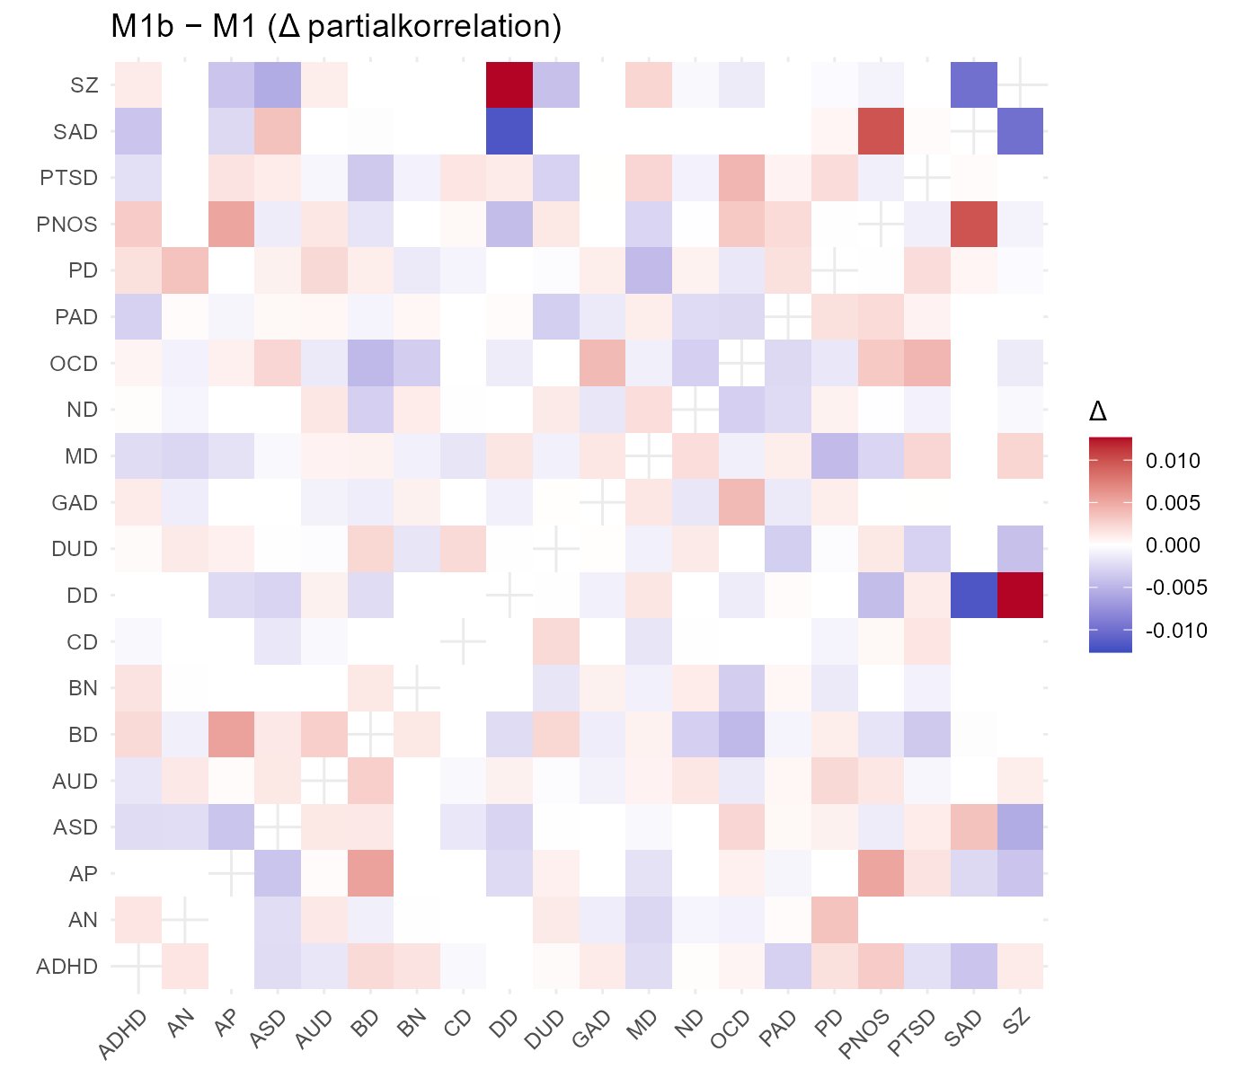

Figure 2 Heat map comparing edge estimates across our split-halves of the primary model (not significant differences, p=0.08)
Tables 6 and 7
Results for the comparison of our edge estimates in primary model in birth cohorts from 1960-1980 and 1981-2000

Var1 | Var2 | Difference: Young-Old | p
DUD | AUD | 0.052 | 0.006
ASD | ADHD | -0.039 | 0.006
ASD | SZ | 0.029 | 0.006
AP | PNOS | 0.023 | 0.006
PTSD | MD | 0.022 | 0.006
BN | AN | 0.018 | 0.006
ND | ADHD | 0.015 | 0.006
CD | ADHD | -0.014 | 0.006
ADHD | DUD | 0.014 | 0.006
DUD | MD | -0.012 | 0.006
ADHD | AUD | 0.012 | 0.006
ASD | BD | 0.012 | 0.006
ND | DUD | 0.011 | 0.006
CD | ND | 0.01 | 0.006
ADHD | BD | 0.009 | 0.006
AN | ADHD | 0.009 | 0.006
ND | AUD | 0.009 | 0.006
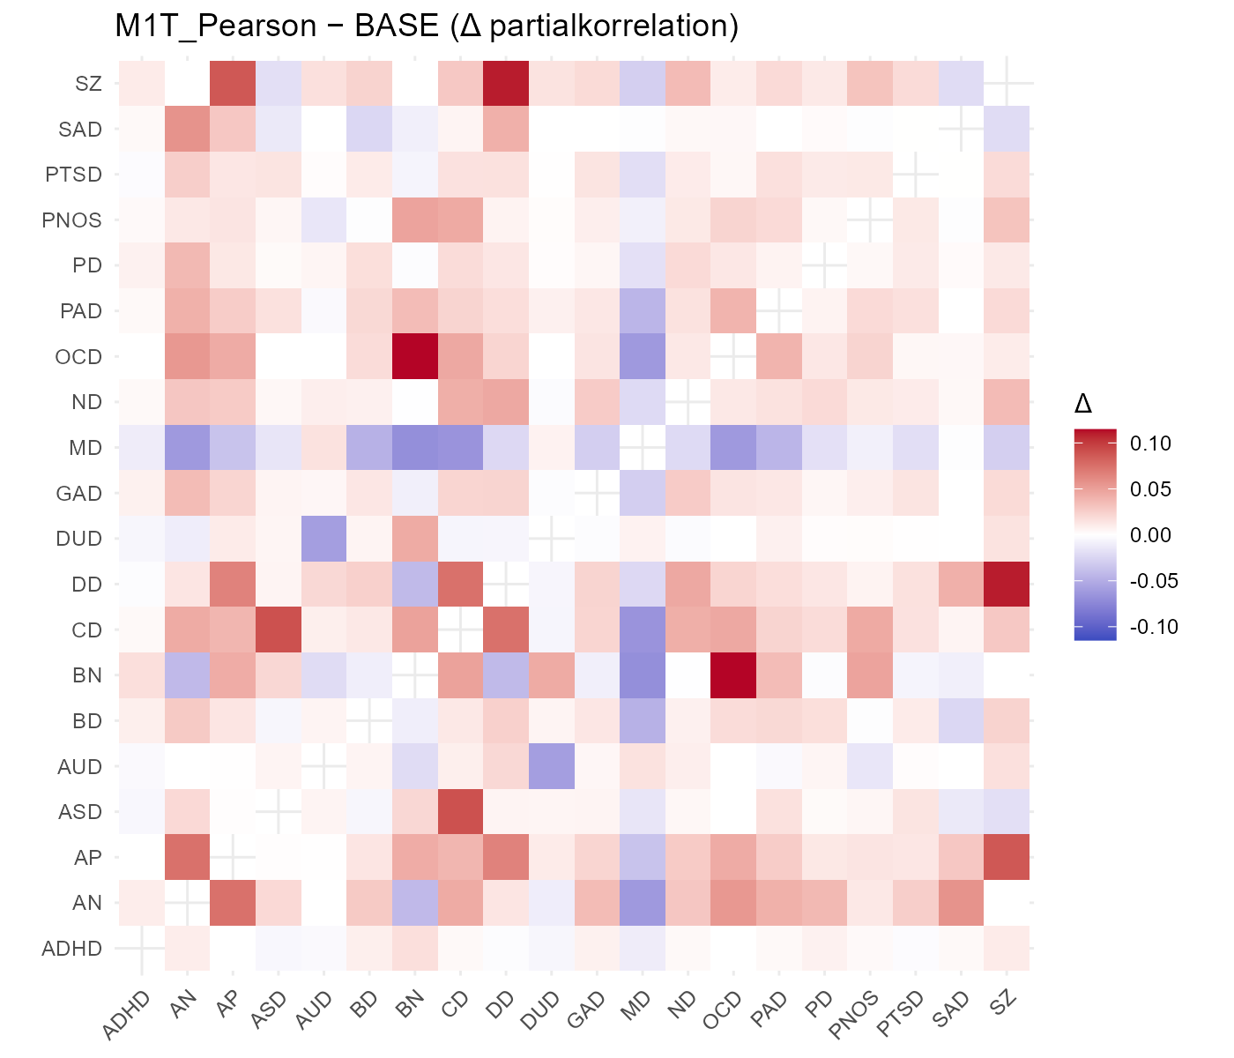

Figure 3 Heat map comparing edge estimates from our original analysis compared with those generated with the use of a Yeo-Johnson transformation (correlation of edge weights: +0.88)

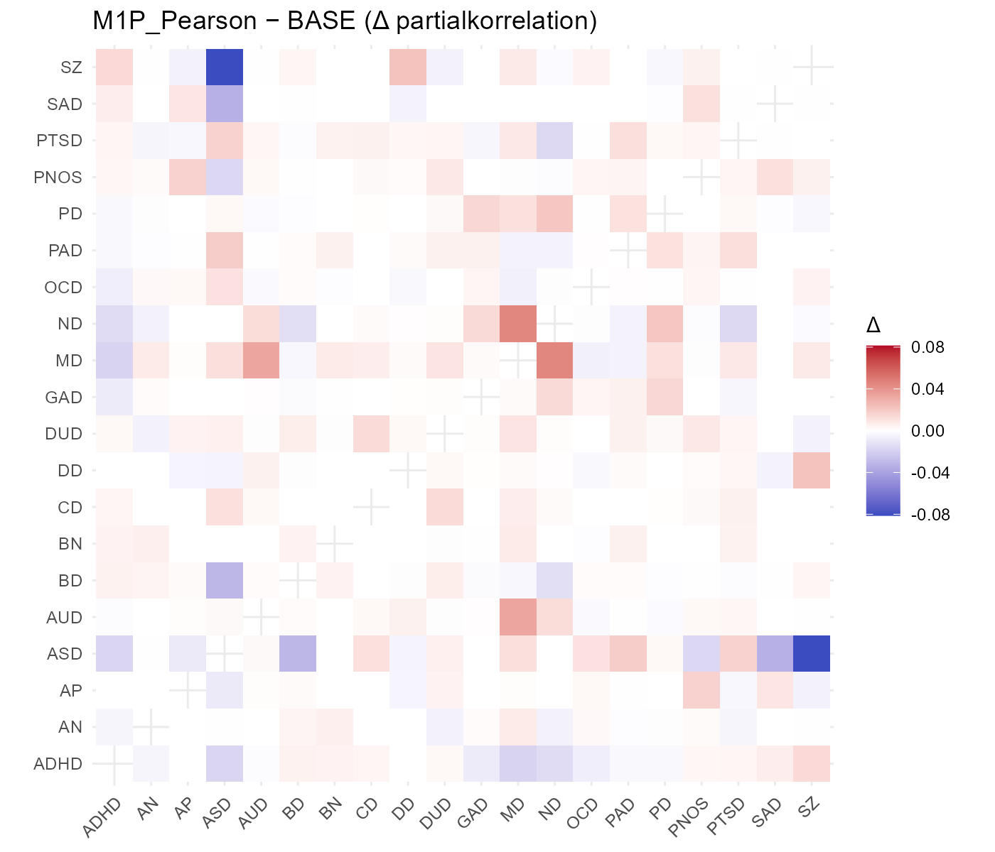

Figure 4 Heat map comparing edge estimates from our original analysis with the standard FGRS compared with those generated using the PA-FGRS of Morten et al (correlation of edge weights: +0.98)

